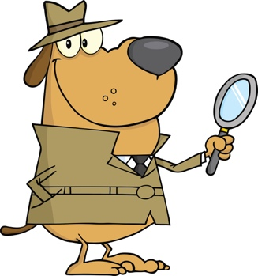
Today, you are going to put your detective hat on and head out into the great outdoors to practice your estimation skills! Below is a chart that will help guide your investigation, as you estimate. Remember to always write down your estimate first, before counting how many or how much there actually is

Here are today’s four detective cases to investigate!

Case | Your Estimate | Actual Number
Case #1: Find a tree that is just beginning to grow buds on its branches. Choose one branch and estimate how many buds you think there are on it. Count the actual number to the best of your ability after you estimate!
Case #2: Take a circular shape, see-through object – like an elastic band or hair tie – and drop it on a patch of grass. Estimate how many blades of grass you think are in the circular object. Then count the actual number!
Case #3: Pick a place around your home to measure – maybe a patch of grass or your drive way. Estimate how many steps (heel-to-toe steps) it will take you to walk from one end to the other. Then actually try it
Case #4: Find a stick and estimate how many finger lengths long it might be. Then measure it out! *Remember you have to use the same finger to measure the whole stick.

